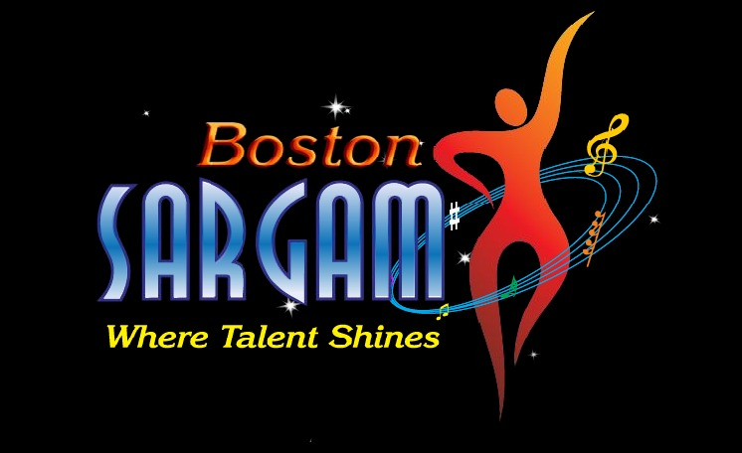 | 2011  BOSTON SARGAM  BOLLYWOOd MUSIC & DANCE  COMPETITION  October 15th, 2011  Registration form

Entries will be accepted by Boston Sargam, Inc. on a first-come, first-served basis. So to secure a spot in the competition, register immediately by emailing this registration form along with your digital audio/video clip to bollywood@bostonsargam.org. On receipt, we will send you an email confirmation. Please print clearly, for Boston SARGAM, Inc. is not responsible for any misspellings unless submitted in typed form.

- Date: / / Independent Entry School Entry

- Entry Category | Solo Song Solo Dance Group Dance
- Personal Information  of Solo Song  & Solo Dance  Contestant  (all fields required) | Name:  Age:  Date of Birth:  Gender:  Email:  Phone:  Mailing Address:
- School Information  (if entry is from the  school) | School Name:  School Director:  Email:  Phone:  School Mailing Address:
- Entry Information  (all fields required) | Song/Dance Name:  Movie/Album Name:  Choreographer/Coach:
- How did you hear  about us? | Flyer Website Direct Mail Teacher Magazine  Newspaper Other ______
- Personal Information of Group Dance Contestants (all fields required)

No. | Name | Age | D.O.B.  dd-mmm-yy | Gender | Email | Phone | Mailing Address
1
2
3
4
5
6
7
8
9
10
11
12

I/we have read and agree to all rules & regulations stated on the website for the 2011 Boston Sargam Bollywood Music & Dance Competition, and by signing and submitting this form I/we agree to comply with and follow all the rules and regulations.

Sign Your Name (print):
Date:

If you have any questions, please send email to: bollywood@bostonsargam.org
You may also visit www.bostonsargam.org for more information.

Boston Sargam, Inc. is a non-profit organization whose aim is to facilitate, showcase & uplift – art, music & all exceptional talent expressions of the South Asian Community to greater levels.

Thank you!
*******

